Brownie Cookie

**Double Chocolate Salted Caramel Brownie Cookie**

**INGREDIENTS**

Servings: 30 - 36

1 box brownie mix  
1 egg  
3/8 cup butter, melted  
½ cup vegetable oil

½ of 11 oz. package of Kraft caramel bits

½ of 12 oz. package of Hershey’s chocolate bits

**PREPARATION**

1. Preheat the oven to 350˚F/175˚C.
2. In a large bowl, combine brownie mix, egg, melted butter, and vegetable oil until dough forms.
3. Stir in caramel bits and chocolate bits.
4. Scoop the dough onto a cookie sheet using cookie scoop and bake for 10-12 minutes.
5. Transfer the cookies to a wire rack and let cool completely.

Note: Dough will be stiff like cookie dough. I use parchment paper to line cookie sheets.

The Best Part: You have ½ packages of caramel and chocolate bits left so you have to make another batch!

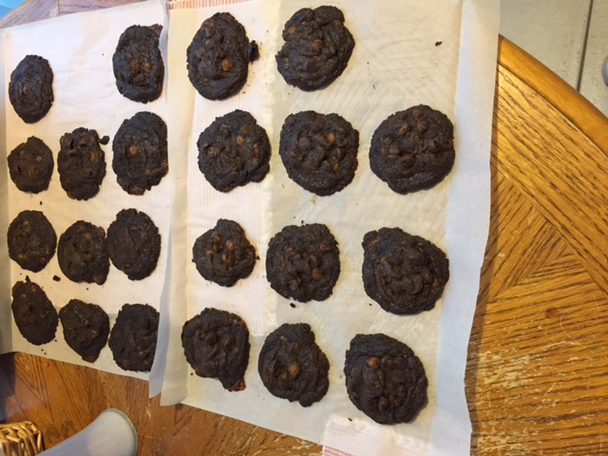

Inspired by: <http://www.tastesoflizzyt.com/buckeye-brownie-cookies/>